FlexDeploy POC

Info
This document describes which parts of OSB delivery process would be good to see in FlexDeploy solution demo.

1. OSB

1.1. FlexPocConfiguration

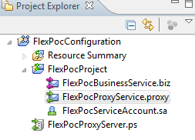

1.2. FlexPocProject
FlexPocBusinessService.biz – replace http://localhost:7001 with another url using OSB customization. Also add ProxyServer to this business service if it needed for specific environment (on build phase)
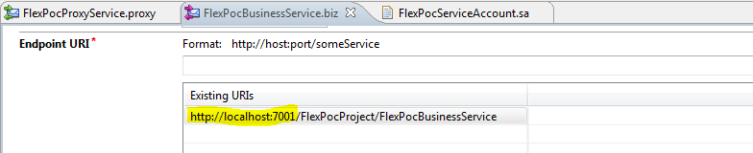

FlexPocProxyService.proxy – replace “@FLEX_POC_SPECIFIC_ENVIRONMENT_VARIABLE@” after build sbcofig.jar with specific environment variable
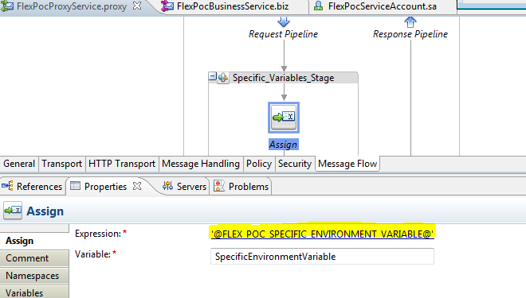

FlexPocServiceAccount.sa – replace “@FLEX_POC_USERNAME@” and “@FLEX_POC_PASSWORD@” with specific environment variables after build sbconfig.jar
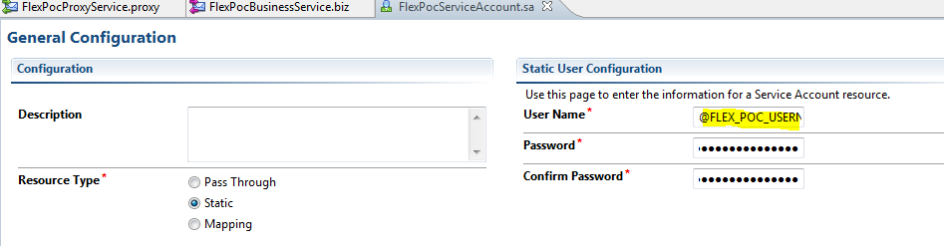

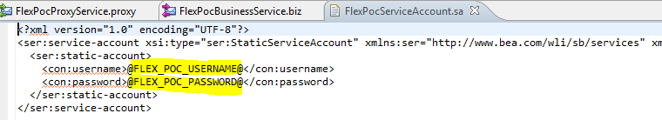

FlexPocProxyServer.ps – replace “@FLEX_POC_PROXY@” with specific environment variable after build sbconfig.jar

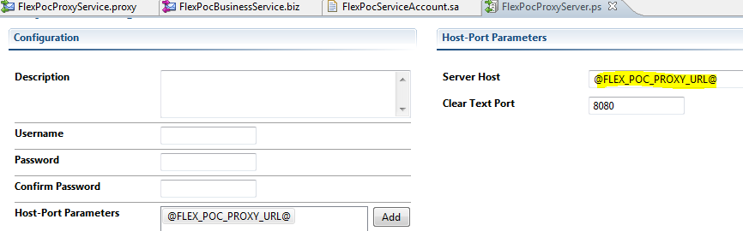

2. Weblogic configuration

2.1. Create DataSource
Create DataSource (with specific environment settings: DB_URL, DB_USERNAME and DB_PASSWORD)

2.2. Create Workmanager
Create MinThreadConstraint (with specific environment settings: MIN_VALUE)
Create MaxThreadConstraint (with specific environment settings: MAX_VALUE)
Create WorkManager using MinThreadConstraint and MaxThreadConstraint

2.3. Create JMS queues
Create JMSServer
Create JMSModule
Create JMSQueue (with specific environment settings: REDELIVERY_DELAY, REDELIVERY_LIMIT)

2.4. Deploy non-OSB WAR/JAR application
Deploy standard (non-OSB) WAR/JAR application

2.5. Add JAR library to Weblogic
Add JAR library to Weblogic “DOMAIN_HOME/lib/” folder (like custom assertion extension library)

2.6. Configure DbAdapter
Add Outbound Connection for DbAdapter (Deployments – DbAdapter – Configuration – Outbound Connection Pools)
For example, create new Outbound Connection “eis/DB/AdapterDB”
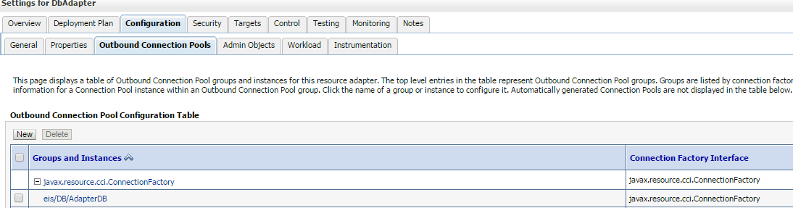
And set datasource “FlexPocDataSource”
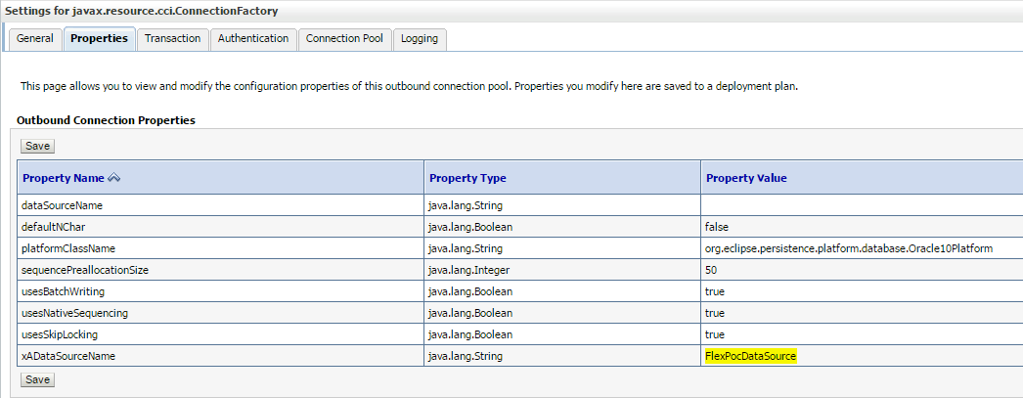

2.7. Configure Realms

2.7.1. Add Users
Create new User and assign it into the group (with specific environment settings: PASSWORD)

2.7.2. Add Groups
Create new Group

